Establishing bus tickets as offering more than just travel

What ? | Offering our customers discounts in locally relevant businesses for them, by flashing their bus ticket/APP.
Why ? | Poor retail footfall in key shopping areas – if a bus ticket gives more than travel it may unlock discretionary spend
Timescales | Establish by December 26 for go live in Jan 27
Measures of success | Increased bus passenger numbers and revenue

Overview

Since January 2026 bus passenger numbers have dropped significantly across Cambridgeshire and Peterborough, currently standing at as high as 23% down compared to last year (this excludes the impact of Busway Fencing).

Drilling into the reasons for this include poor retail footfall (down 3.8% in year in Cambridge in August; 2.1% in the eastern region, compared to 1.8% at a national level). Employment levels are good at around 78% across the region. Data for working from home is hard to find but incidental data we have from rail strikes shows Cambridgeshire and Peterborough to be an area where work from home is a preferred option as opposed to driving (rail passenger data is good and growing).

Stagecoach in the 80S and 90s had a deal whereby on the back of bus tickets was a voucher for a cheap McDonalds. We currently have a deal with Reward Bag for our APP which offers discounts on things like Gusto Boxes. To tempt out discretionary spenders, either resident or visitor we need to offer discounts relevant to Cambridgeshire and Peterborough which people identify with. Regs on promoting high fat and sugar foods to young people need to be considered but these only kick in where more than 50% of customers are under 15 and bus and rail passengers don’t hit that criteria.

The deal with McDonalds only stopped because of concern by a former senior leader of our brand being associated with high fat and sugar products. The deal, then with Ticket Media, offered us free ticket rolls and a small amount of advertising revenue. The Ticket Master deal still exists, and we could potentially reactivate the McDonalds deal fairly quickly.

To get firms to offer discounts and publicise the scheme, a PR release – Stagecoach the Consumers’ Champion can get first firms for the scheme and then to build awareness. This costs us nothing.

Will it gain us new passengers or simply offer our existing customers a discount ? Here, it is key to remember that the discounts and publicity through press releases would not cost us anything. In addition, if people can see a bus ticket as offering them more than bus travel, and the discount is a meaningful one, there is a very good chance it can lead to them giving bus a go.

What is the plan ?

Core to the success of this, is an understanding that advertising revenue is nice, as is cheap ticket rolls,the key consideration must be – can the partner offer a discount which is attractive to the widest possible demographic of our customers.

Starting with our ticket rolls, the Ticket Media deal is in place and so all we need to do is to help them to gain more partners. They have the focus and passion to deliver this; are extremely confident they will deliver McDonalds and will be highly likely to work with firms identified by Stagecoach Commercial Directors.

The only thing which paused the McDonalds deal before was a former member of Exco. Analysis was asked for, on would our customer base be compliant on high fat and sugar product regs. This analysis from 2025 showed we were. The only potential risk areas are on dedicated school services which don’t do any other bus work. This can easily be solved though by ensuring that any services which meet these criteria use ticket rolls with a different advertising partner.

Turning to Reward Bag, who currently have a contract in place until May 27.

There initial partners have evolved to:

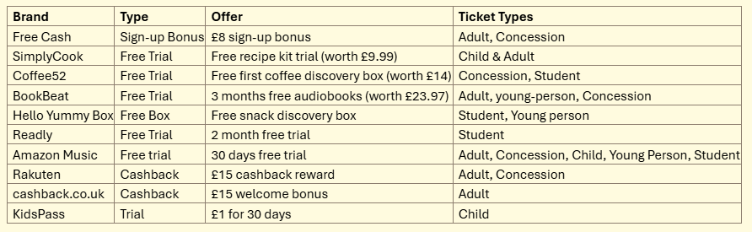

These will engage with some of our clients but not with all. To encourage our customers to see the bus ticket as more than a bus ticket and so travel more than usual it needs to offer them discounts in locally relevant retailers they identify with.

Work is therefore ongoing with Reward Bag to both refocus them, get them to work with local CD’s to find offers, and push them to do better on the basis that their current offer and the revenue generated by it is disappointing. Their focus again needs to be firmly the attractiveness of the customer offer.

As their contract is up for review in May 27, they obviously have a short time window to correct this.

Timescales

If these measures can be established during October and November 26, we could go for a soft launch for Christmas 2026 and then capitalise on this for Easter 2027.

Measures of success

We would benchmark the success of this initiative based on pre-launch:-
- Bus passenger numbers
- Revenue numbers
- East APP customer numbers and sales levels

Success can then be defined as any major improvement in the base line numbers.

We can also add as success metrics:-
- Number of offer redemptions

